|  |  |
| --- | --- |
|  | **MS in Business Analytics & Project Management** |

**OPIM 5641- Business Decision Modeling**

**Fall 2016**

**Icebergs for Kuwait**

**Team-3  
Amit Madhup  
Abhinav Suggula  
Seshi Harianathan  
Ziou Zhang**

**Project Final Report**

**Executive Summary**

The Middle-Eastern countries especially Kuwait is facing extreme water scarcity and is looking for options to provide pure water to residents in the most economical way. A traditional approach to address this problem is desalinating sea water from the Persian Gulf, but past studies have suggested a more cost efficient option of towing icebergs from Antarctic. In order to determine the economic viability of the new process, we need to consider multiple parameters including towing vessel details, the rate at which the iceberg melts, fuel cost for the towing vehicles and the volume of ice as part of the analysis and decide whether this approach will be economically beneficial for the Kuwait Government and whether it will help them to reduce the current costs and minimize the oil quantities required for desalination. With the help of the analytical techniques and sensitivity analysis we have found out that the new process of towing the icebergs is economically feasible for only two cases where the volume of the iceberg is 10,000,000 cu. meter and the ship’s speed is either 3 kmph or 5 kmph. In all other scenarios, the new process costs are greater than the cost of desalination using the traditional process.

**Problem Description**

The high demand for pure water in Kuwait requires us to determine the economic feasibility of producing fresh water from the icebergs in the Persian Gulf and we must also identify the best method for towing the icebergs. We need to address few challenges including the fact that the icebergs are melted at various rates during the travel thereby leading to a variation in the volume and the radius of the icebergs.

**Analysis**

1. **Scenario analysis:**

The cost per cu. meter of towing the iceberg is calculated by varying the volume of the iceberg from 500,000 to 10,000,000 cu.meter for different speed levels of the ship of 1, 3 and 5 kmph. We are considering the fact that we are starting with the maximum amount of ice a ship can hold. It can be found that the cost of water is economically feasible for only two scenarios where the volume is 10,000,000 cu.meter and the speed of the ship is 3 kmph and 5 kmph. Whereas the other scenarios are proving to cost greater than the traditional desalination process.

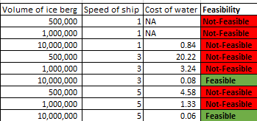

1. **Tornado chart analysis:**

The Tornado charts are created for different levels of speed in order to identify the important input variables which are influencing the output variable, cost per cu.meter of water.

1. **Speed of ship = 1 kmph:**

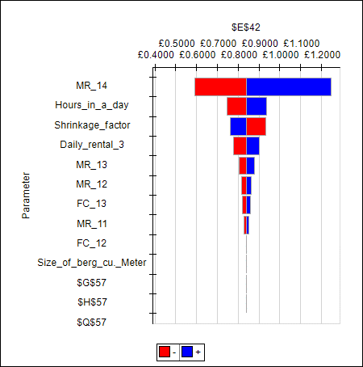

When the speed of the ship is 1kmph, we can see that the most important factor affecting the cost is melting rate for the distance >4000 km because this is influenced by the maximum amount of distance throughout the journey. The other variables include the hours in a day and shrinkage factor (constant variables) and the melting rates for the distance = 3000 km and distance = 2000 km.

1. **Speed of ship = 3 kmph:**

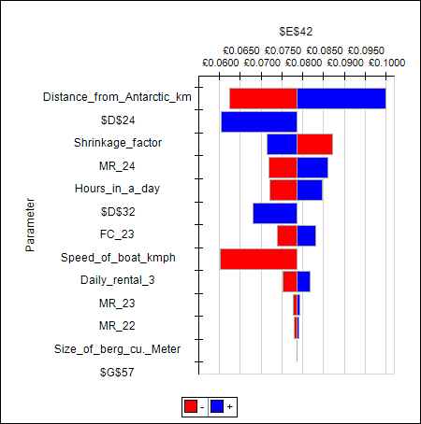

When the speed of the ship is 3kmph, we can see that the most influential factor is distance which is a constant parameter, followed by the speed of ship and shrinkage factor. These are followed by melting rate for the distance >4000 km, hours in a day and fuel cost (10,000,000 cu.meter).

1. **Speed of ship = 3 kmph:**

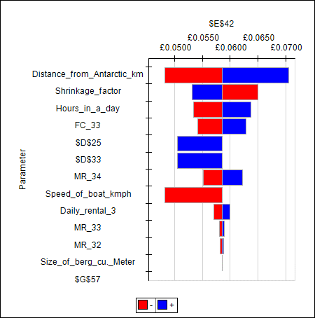

When the speed of boat is 5 kmph, the top three factors are constant namely distance, shrinkage factor and hours in a day. They are followed by fuel cost (10,000,000 cu.meter), speed of ship, melting rate for the distance >4000 km, etc.

Overall for the cases where speed of boat is 3 kmph or 5 kmph, the factors affecting the output are very similar while for the case of 1 kmph the factors differ substantially.

1. **Sensitivity Analysis:**
2. **Volume of the iceberg when Speed of ship = 1 kmph:**

The sensitivity chart is constructed by varying the size of ice berg from 100,000 to 10,000,000 cu.meter by keeping the speed of ship constant as 1 kmph. This shows an adverse effect on the cost, but still the traditional method fares are well compared to the cost of new process.

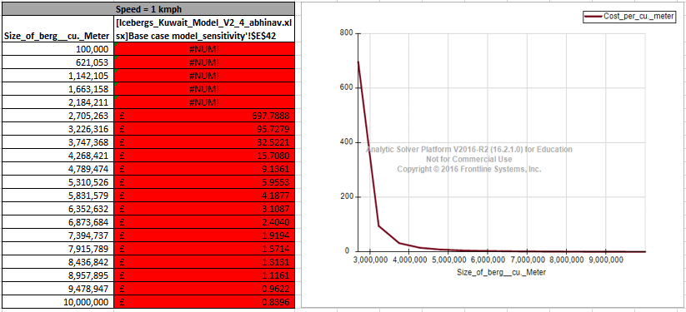

1. **Volume of the iceberg when Speed of ship = 3 kmph:**

The sensitivity chart for case of speed 3 kmph, we can see that varying the size of ice berg has an inverse effect on the cost. The volume of iceberg has to be greater than ~8.5 million cu.meter so that the cost of new method becomes less than traditional method.

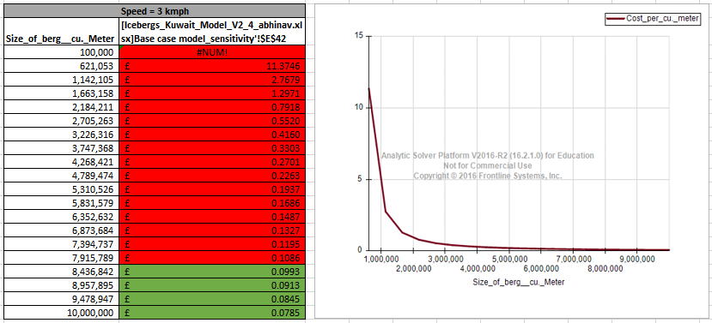

1. **Volume of iceberg when Speed of ship = 5 kmph:**

The sensitivity chart for speed = 5kmph shows an inverse relationship between the size of ice berg and the cost, which is very similar to case of speed = 3 kmph. The volume of iceberg in this case has to be greater than ~6.5 million cu.meter so that the cost of new method becomes less than traditional method.

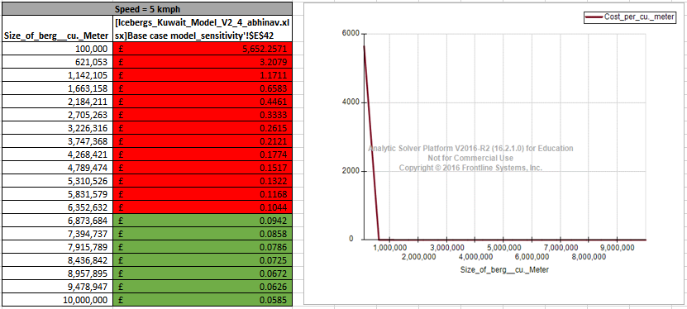

1. **Extension to different location:**

The below analysis is made to determine if the towing process can be applied to different locations apart from the Antarctic. It can be found that this process can be applicable to different locations when the speed of the ship is 3 kmph and 5 kmph whereas it is not feasible when the speed is 1 kmph.

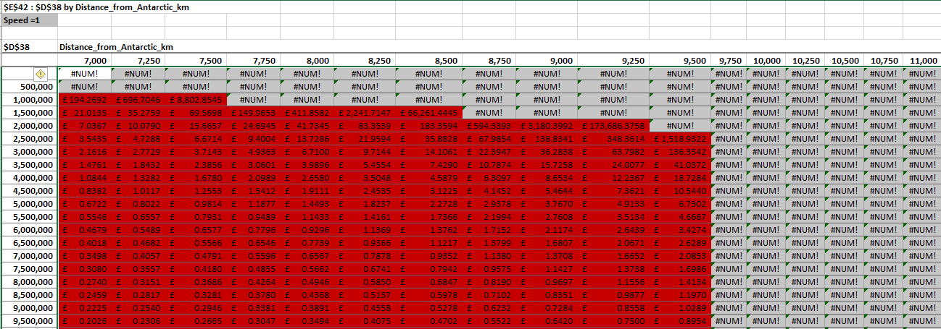

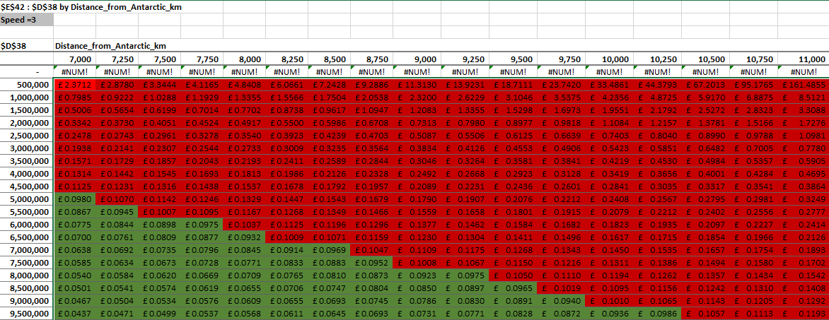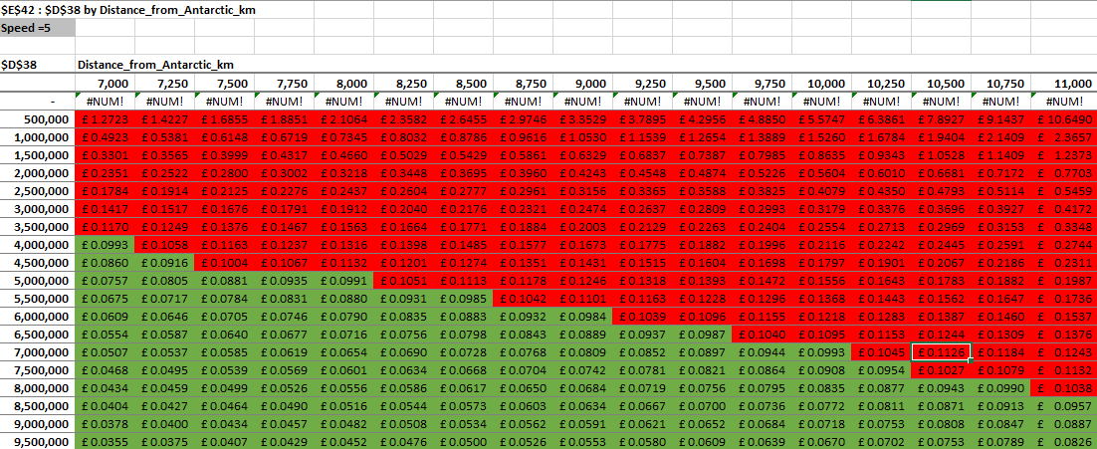

1. **Break even Analysis:**
2. **Volume of ice berg:**

When the speed of the ship is 3 kmph, the breakeven point to attain a cost less than that of traditional method is 8.4 million cu.meter.

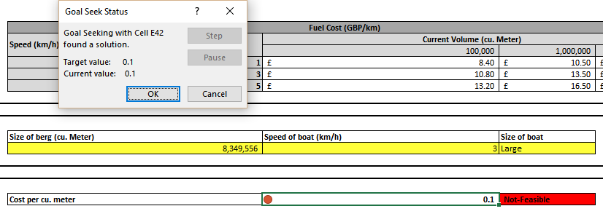

When the speed of the ship is 5 kmph, the breakeven point to attain a cost less than that of traditional method is 6.6 million cu. meter.

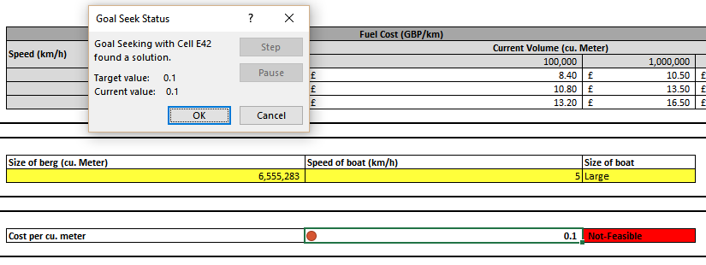

1. **Rental cost:**

We can see from the below breakeven analysis that only 2 cases are feasible for towing considering the maximum amount of ice each ship can carry. Considering other parameters constant, we can see that the maximum fuel cost could go from 800 GBP to 1338 GBP for the case when speed of ship is 3 kmph and 800 GBP to 3053 GBP for the case when speed of ship is 5 kmph which is an increase of 67% and 282% respectively.

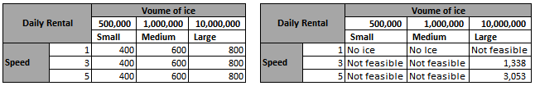

**Conclusion:**

We conclude by saying that the best economic scenario occurs when the speed of the iceberg and the volume of the berg are at their maximum values of 5 kmph and 10,000,000 cu. meter respectively. The towing process will be profitable when a minimum quantity of approx. 8.5 million cu.meter of ice is towed with the speed of the ship being 3 kmph and when a minimum quantity of approx. 6.5 million cu.meter of ice is towed with the speed of the ship being 5 kmph. Also, we can see that these two are the most important factors influencing the output variable – cost per cu.meter of water.